Bhartiyam International School
Periodic Assessment -1(2022-23)
Subject: EVS (Set-A)
Class: II
Date: 13/07/2022 Max. Mark: 20
Name: ______________ Roll No: ______ Duration: 1 hr
Instructions:
- All the questions are compulsory.
- Attempt all the questions in neat and clean handwriting.
A. Choose the correct options: (0.5x6=3)
1. I use my _______________ to taste food.
a) ears b) eyes c) feel d) tongue
2. The first help given to an injured person is called __________________.
a) doctor b) no aid c) first-aid d) safety
3. Which of the following games is an outdoor game?
a) Ludo b) Carrom c) Cricket d) Chess
4. Keeping away from danger is called _________________.
a) safety b) fire c) injury d) rules
5. Skin helps us to touch and _______________.
a) hear b) see c) feel d) taste
6. Which of the following is an internal organ?
a) Brain b) Limbs c) Skin d) Eyes

B. Match the following: (0.5x6=3)
(1) Arms, Legs (a) form of exercise

(2) Indoor Game (b) zebra crossing
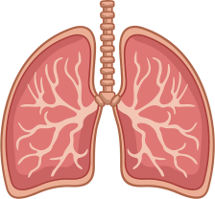
(3) Cross road (c)

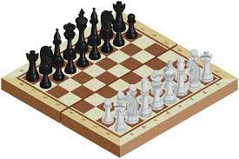
(4) Internal organ (d) limbs

(5) Walking (e)

(6) Good posture (f) proper shape to our body

C. Fill in the blanks: (1x4=4)
1. We should stand ____________________.
2. We should hold the handlebar of a bicycle __________________.
3. Eating _______________ food can make you fall sick.
4. ________________ pumps the blood.
D. Write T for true and F for false: (1x4=4)
1. Brain helps us to think.
2. We should play with sharp objects.
3. Wearing clean clothes is a good habit.
4. Safety rules are bad for us.
E. Answer the following questions: (2x3=6)
1. Write any two good eating habits.
____________________________________________________________________________________________________________________________________________________________________________________________________________________________________

____________________________________________________________________________________________________________________________________________________________________________________________________________________________________

2. State two safety rules while riding a bicycle.
____________________________________________________________________________________________________________________________________________________________________________________________________________________________________

____________________________________________________________________________________________________________________________________________________________________________________________________________________________________

3. Name some forms of exercise.
____________________________________________________________________________________________________________________________________________________________________________________________________________________________________

____________________________________________________________________________________________________________________________________________________________________________________________________________________________________

